Introduction to Musica got talent

A brief introduction: Musica got talent is a competition to select the best candidate in Musica for the UBN’s got talent. This contest bases on raw talent and reaction of the audience for the competitor. The jury decides which performance will go on the next round. The winner will represent Musica to attend the global competition.

Event purpose: To find the representative who not only has a remarkable talent and stands for our country vision, mission and DNA.

Target audience: All citizens of Musica have the right to participate in this contest.

Key Message: “The star rising from the ashes”

Event Theme:
- Decoration: No decoration for the venue (stage, backstage and foyer, including no umbrella for the stage if it rains). The idea of the stage is similar to the ancient Greek theatre with mountains behind as the background.
- Entertainment: guests: some important artists, 2 people from national anthem, and a randomly individual picked from the streets of Musica.

Event Staff: Besides members of Department of Sport, Culture and Tourism taking leading positions in the event team, others contributing to this contest are volunteers.

Event Timeline: We will start early in the morning so that people who have special effects, for example something with fire, can perform their act. The talent show will start at 5 am and finish at 11 pm. We will work with a lot of daylight and some torches in the evening to create a cosy atmosphere. This will go on for 2 weeks and each day there will be another judge picked from the streets.

Venue: The Theatre

Event Logistics: No equipment will be needed including lighting, amplifier/ microphone. No catering or tea break for the jury, the guests and the participants due to extremely low budget from the government.

Promotion and Marketing:
- Encourage people to subscribe on the Internet
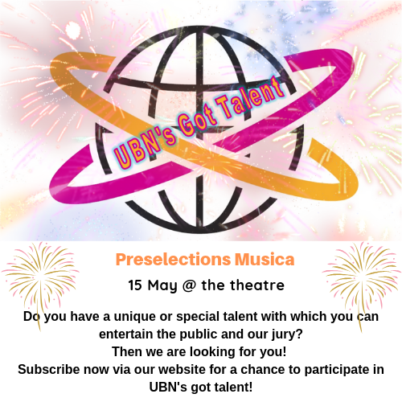
- Hot air balloons flying over the country with advertisements printed on them



- Advertising on TV in the evening while everybody is together watching TV (one TV per street)
- Everyone can come to the competition because it’s free of charge

Budget Outline: There is absolutely no budget available for these kinds of events. So, the participants need to bring their own props. The only thing Musica as an institution will provide are the torches used to bring light in the darker hours in the evening.

